WinFrog Vehicle 1 Settings Guide

- PURPOSE
The purpose of this procedure is to detail the steps involved for all Vessels requiring Winfrog Vehicle 1 Settings.

- SCOPE
This procedure applies to all employees within the Organization.

- RESPONSIBILITY AND AUTHORITY
The Technical Director has the responsibility and authority for ensuring that this procedure is effectively implemented.

- Procedure
  - Right-Click on “Vehicle-1 and select “Setup Data Events”. See Figures 1 - 3.

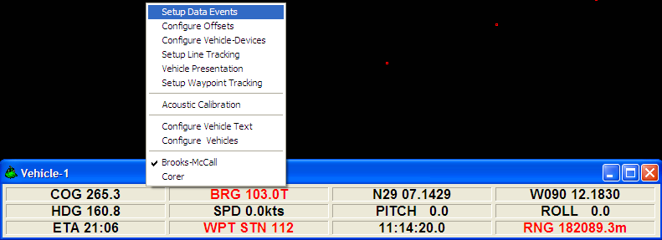
Figure 1

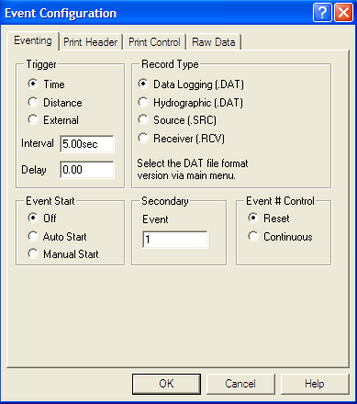
Figure 2

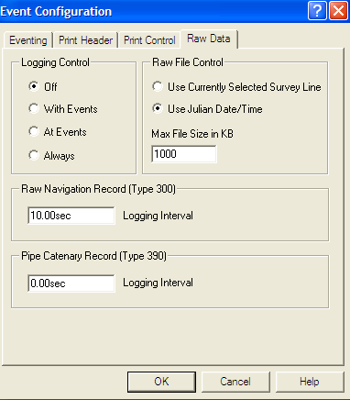
Figure 3

  - Right-Click on “Vehicle-1 and select “Configure Offsets”. See Figures 4 & 5.

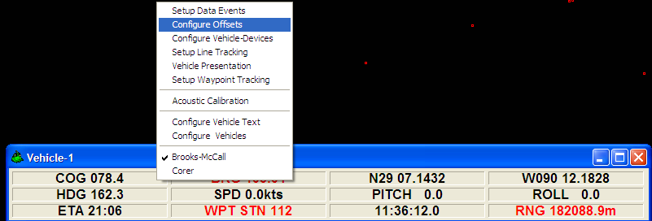
Figure 4

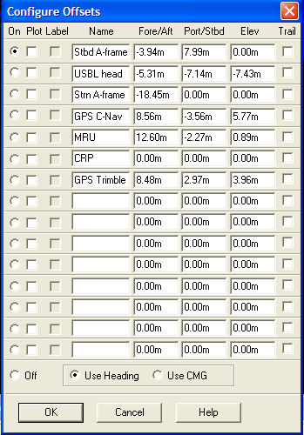
Figure 5

  - Right-Click on “Vehicle-1 and select “Configure Vehicle-Devices”. See Figures 6 & 7.

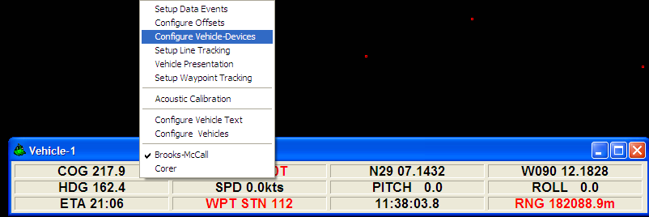
Figure 6

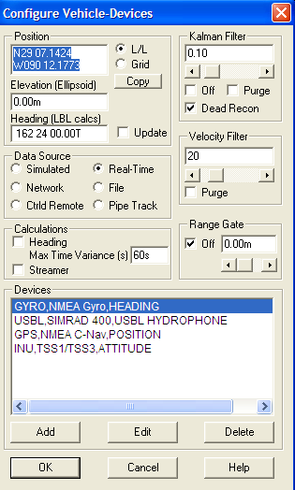
Figure 7

  - Right-Click on “Vehicle-1 and select “Setup Line Tracking”. See Figures 8 & 9.

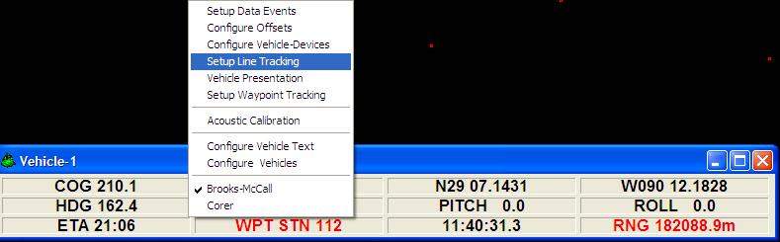
Figure 8

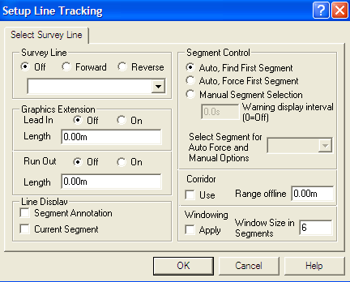
Figure 9

  - Right-Click on “Vehicle-1 and select “Setup Waypoint Tracking”. See Figures 10 & 11.

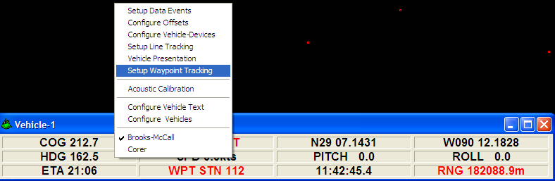
Figure 10

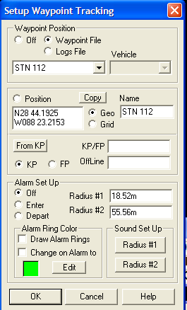
Figure 11

  - Right-Click on “Vehicle-1 and select “Acoustic Calibration”. See Figures 12 & 13.

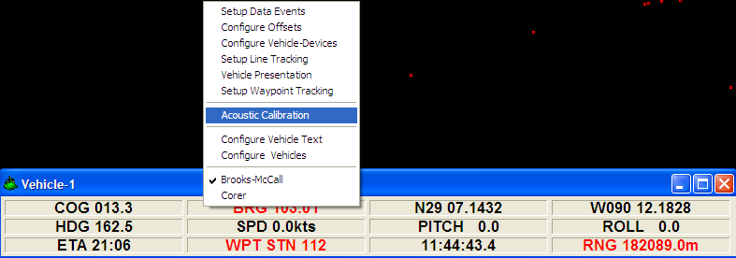
Figure 12

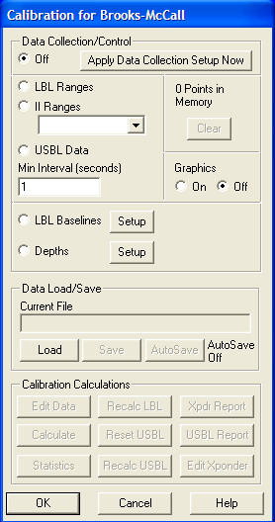
Figure 13

  - Right-Click on “Vehicle-1 and select “Configure Vehicle Text”. See Figures 14 & 15.

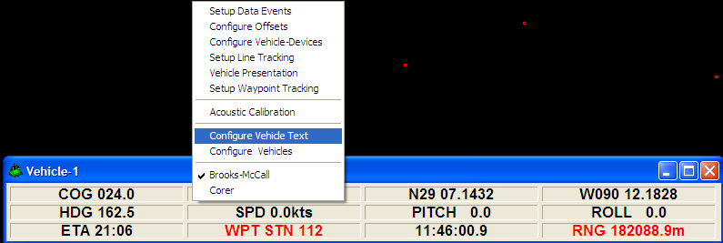
Figure 14

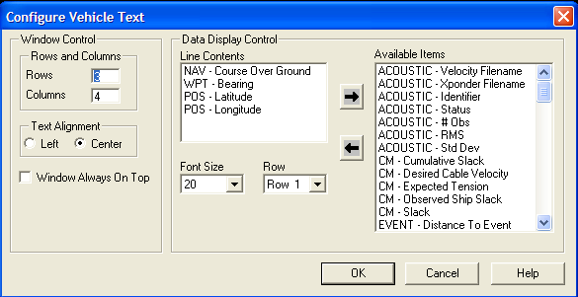
Figure 15

  - Right-Click on “Vehicle-1 and select “Configure Vehicles”. See Figure 16.

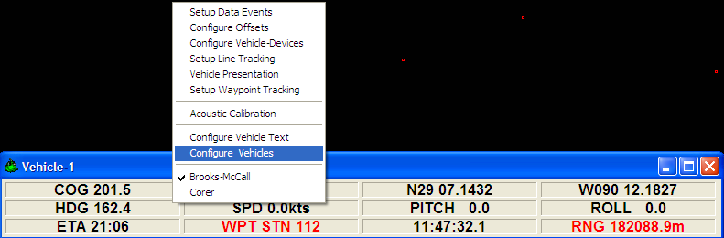
Figure 16
  - Select “Configure Vehicle Outline”. See Figures 17 & 18.

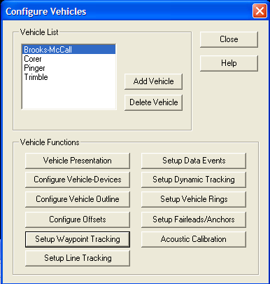
Figure 17

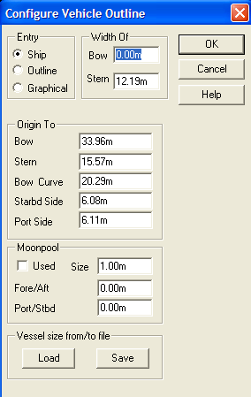
Figure 18

  - Select OK > and select “Setup Dynamic Tracking”. See Figure 19.

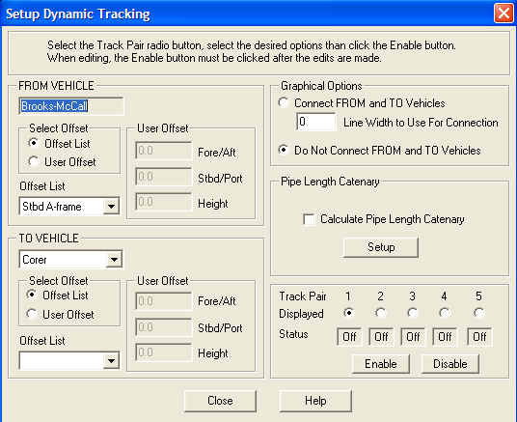
Figure 19

- RELATED DOCUMENTATION

- Revisions

Section | Description | Date | Approved by:
 | Initial Release | 6-30-10 | G. Patterson

